Manuscript Pattern – General Requirements

Please read these instructions carefully!

We recommend using the following pattern to produce your manuscript for PCIM Asia.

Deadline for submission is 20 June 2024
Please send your manuscript as PDF file.

About the file:
– Please note, that the size of your manuscript is web-optimized and hence should not exceed 5 MB.
– Please ensure that all fonts and pictures or tables are embedded in the final PDF-file.

General instructions:

The number of pages is restricted to a maximum of 8 pages.
Each page should be in a two-column format. The column width is 8.59 cm on European A4 size (210 mm x 297 mm). Regarding the references, give all authors’ names; do not use “et al.” unless there are six or more authors.

The margins have to be set up as follows:
Top margin to the first line: 2.0 cm
Bottom margin to the last line: 2.5 cm
Left margin to the text: 1.7 cm
Right margin to the text: 1.7 cm

Font sizes:
Text | Letter Type | Size | Art
Title | Arial | 16 points | Bold
Body text | Arial | 10 points
Header | Arial | 14 points | Bold
Subheader | Arial | 12 points | Bold
Captions | Arial | 10 points
Tables header | Arial | 10 points | Bold
Tables | Arial | 10 points
Reference | Arial | 10 points

Please ensure that all fonts and pictures or tables are embedded in the final PDF-file.
Furthermore, please use 12 pt line spacing for the text and justify the text (i.e. align the text to both the left and the right margins). Please make no indication of page numbers as it will be carried out by the publisher.

Your Paper Title – (16 pt, bold, max. 2 lines) Please Capitalize the Initial Letters of Your Title Except Prepositions and Articles

Author's first name and surname¹ , Co-author’s first name and surname¹ , Co-author’s first name and surname² , Co-author’s first name and surname³
(Add or delete lines if necessary, please link here your ORCID ID, delete the icon, if not
appropriate)
¹ company name, country
² company name, country
³ company name, country

Corresponding author: Author’s first name and surname, e-mail-address
Speaker: Speaker’s first name and surname, e-mail-address

Abstract
The abstract gives a condensed summary of the content of your paper. It is a single paragraph formatted in a justified single column. It does not contain references. This is a normal text in 10 pt type size and 12 pt line spacing. This is a normal text in 10 pt type size and 12 pt line spacing. This is a normal text in 10 pt type size and 12 pt line spacing.

1st Order Heading

2nd Order Heading

3rd Order Heading
This is a normal text in 10 pt type size and 12 pt line spacing. This is a normal text in 10 pt type size and 12 pt line spacing. This is a normal text in 10 pt type size and 12 pt line spacing. This is a normal text in 10 pt type size and 12 pt line spacing. This is a normal text in 10 pt type size and 12 pt line spacing. This is a normal text in 10 pt type size and 12 pt line spacing.

2nd Order Heading
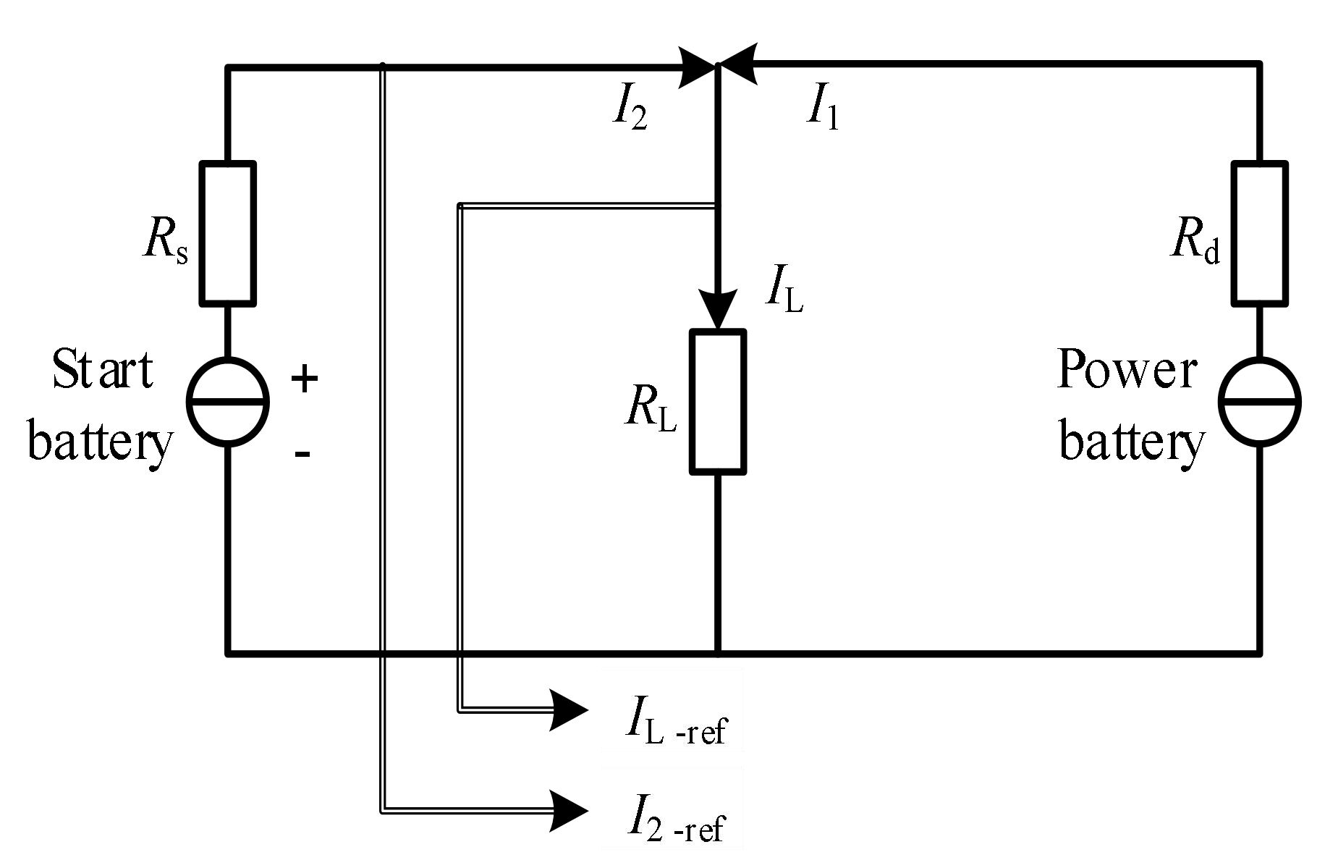
Fig. 1. This is the title of image (Image with text in line)
This is a normal text in 10 pt type size and 12 pt line spacing. This is a normal text in 10 pt type size and 12 pt line spacing. This is a normal text in 10 pt type size and 12 pt line spacing. This is a normal text in 10 pt type size and 12 pt line spacing. This is a normal text in 10 pt type size and 12 pt line spacing. This is a normal text in 10 pt type size and 12 pt line spacing.

3rd Order Heading
This is a normal text in 10 pt type size and 12 pt line spacing. This is a normal text in 10 pt type size and 12 pt line spacing. This is a normal text in 10 pt type size and 12 pt line spacing. This is a normal text in 10 pt type size and 12 pt line spacing. This is a normal text in 10 pt type size and 12 pt line spacing.

1st Order Heading
This is a normal text in 10 pt type size and 12 pt line spacing. This is a normal text in 10 pt type size and 12 pt line spacing. This is a normal text in 10 pt type size and 12 pt line spacing. This is a normal text in 10 pt type size and 12 pt line spacing. This is a normal text in 10 pt type size and 12 pt line spacing. This is a normal text in 10 pt type size and 12 pt line spacing.

2nd Order Heading
This is a normal text in 10 pt type size and 12 pt line spacing. This is a normal text in 10 pt type size and 12 pt line spacing. This is a normal text in 10 pt type size and 12 pt line spacing. This is a normal text in 10 pt type size and 12 pt line spacing. This is a normal text in 10 pt type size and 12 pt line spacing.
This is a normal text in 10 pt type size and 12 pt line spacing. This is a normal text in 10 pt type size and 12 pt line spacing. This is a normal text in 10 pt type size and 12 pt line spacing. This is a normal text in 10 pt type size and 12 pt line spacing. This is a normal text in 10 pt type size and 12 pt line spacing.

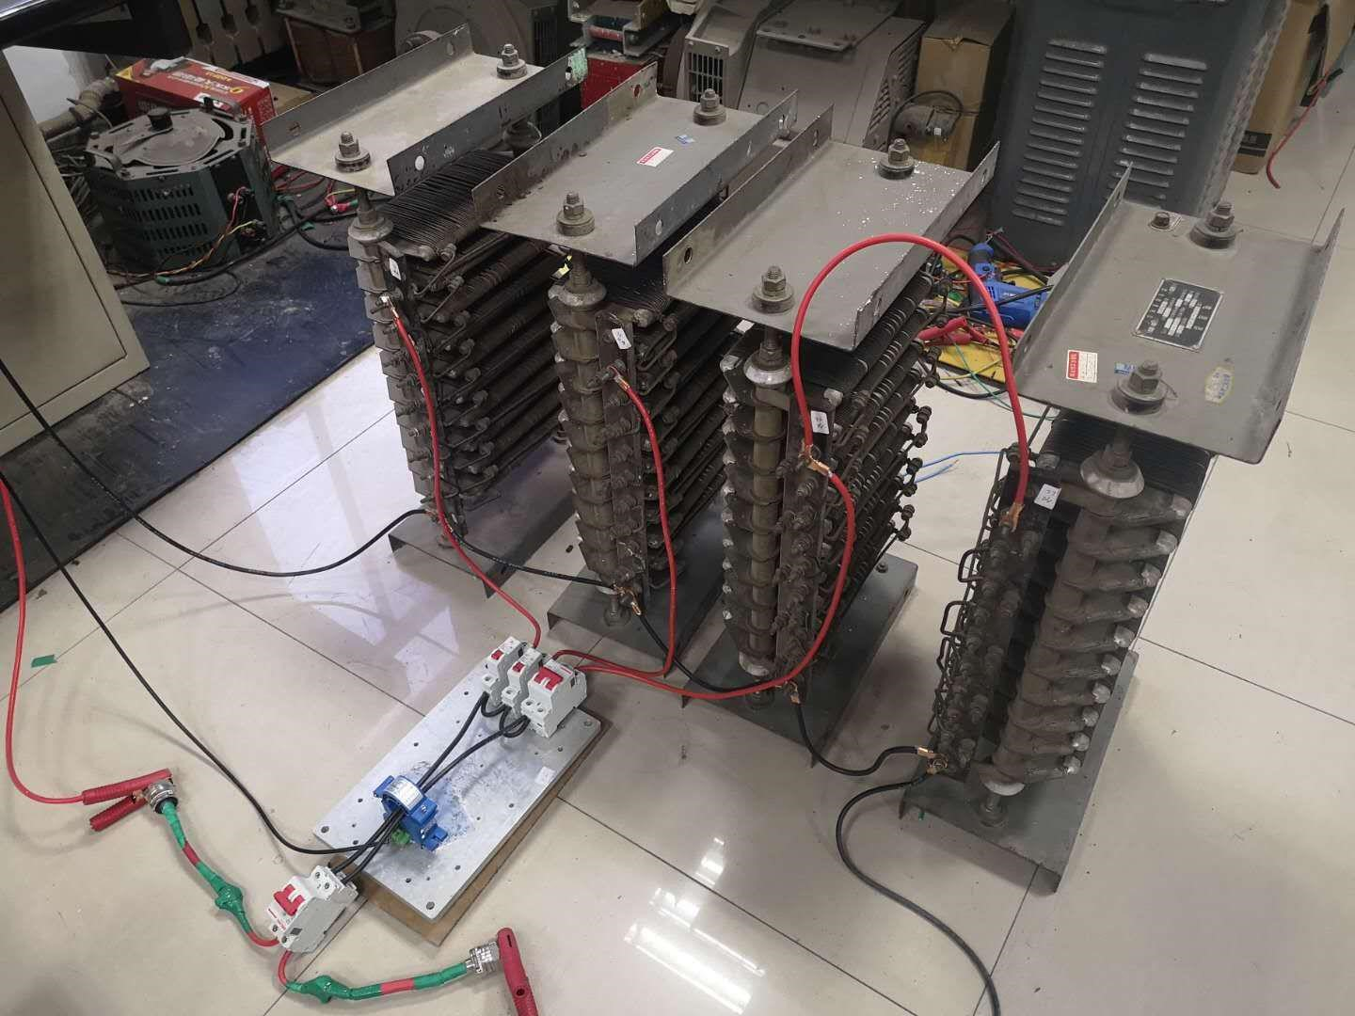
Fig. 2. This is the title of image (Image with text in line)

- List paragraph
- List paragraph
- List paragraph
- List paragraph

References
[1] M. Held, P. Jacob, G. Nicoletti, P. Scacco, M. H. Poech: Fast Power Cycling Test for IGBT Modules in Traction Application, Proc. Power Conversion and Drive Systems 1997, 425-430.
[2] H. Kabza, H.-J. Schulze, Y. Gerstenmaier, P. Voss, J. Wilhelmi, W. Schmid, F. Pfirsch, K. Platzöder: Cosmic Radiation as a Cause for Power Device Failure and Possible Countermeasures, Proc. ISPSD 1994, 9-12.
[3] H. Kabza, H.-J. Schulze, Y. Gerstenmaier, P. Voss, J. Wilhelmi, et al.: Cosmic Radiation as a Cause for Power Device Failure and Possible Countermeasures, Proc. ISPSD 1994, 9-12.
[4] J. Lutz, H. Schlangenotto, U. Scheuermann, R. De Doncker: Semiconductor Power Devices, 2nd Ed., Springer, 2018, DOI 10.1007/978-3-319-70917-8.
[5] S. Ramminger, N. Seliger, G. Wachutka: Reliability Model for Al Wire Bonds Subjected to Heel Crack Failures, Microelectronics Reliability 40, 1521-1525, 2000.

